Summer 2022 Challenge Life Basketball Camp
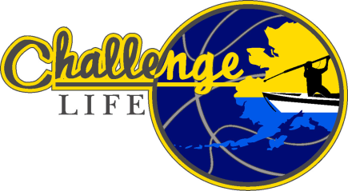
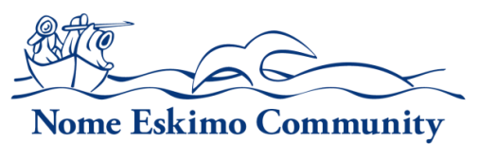

Nome Eskimo Community and Challenge Life Youth Foundation are proud to sponsor the Triple Threat Hoop Camp.

Camp will be held at the Nome Rec Center Gym on August 8th – 12th
For individuals in grades 1st – 12th.

Camp directors will be Al Sokaitis, the founder of the Challenge Life, and assistant coaches Justin Bourne, and Amy Sokaitis.

Spaces are available on a first come first serve basis. Early registration is highly recommended.

********************************************************************************

Registration forms need to be returned to Nome Eskimo Community
no later than Friday, August 5th, 2022.

********************************************************************************

CAMP SCHEDULE
1st – 2nd grade 9:00 – 9:45 AM
3rd - 5th grade: 10:00 – 11:30 AM
6th – 7th grade: 12:00 – 1:45PM
6th-12th grade: 2:30 – 4:30 PM

********************************************************************************

Triple Threat Hoop Camp Individual Registration Form

1.

/ /
Athlete’s First Name Last Name Age DOB Grade Gender

Email Address

Mailing Address City State Zip
______________________________________________________________________________________
Pre-Existing Conditions Allergies (Medicines or Food)

Parent/Guardian First Name Last Name

Parent/Guardian Day Phone Number Parent/Guardian Home Phone Number

Emergency Contact (Other than parents) Emergency Contact Phone Number

Race Alaska Native African American Asian/Pacific Islander Caucasian

Hispanic American Indian Other

Are you enrolled in Nome Eskimo Community? Yes No

Shirt Size ☐ Youth S ☐ Youth M ☐ Youth L ☐ Adult S ☐ Adult M ☐ Adult L

2.

/ /
Athlete’s First Name Last Name Age DOB Grade Gender

Mailing Address City State Zip
______________________________________________________________________________________
Pre-Existing Conditions Allergies (Medicines or Food)

Parent/Guardian First Name Last Name

Parent/Guardian Day Phone Number Parent/Guardian Home Phone Number

Emergency Contact (Other than parents) Emergency Contact Phone Number

Race Alaska Native African American Asian/Pacific Islander Caucasian

Hispanic American Indian Other

Are you enrolled in Nome Eskimo Community? Yes No

Shirt Size ☐ Youth S ☐ Youth M ☐ Youth L ☐ Adult S ☐ Adult M ☐ Adult L

1. I, the undersigned parent/guardian of the individual named above, a minor, do hereby agree to allow the individual named herein to participate in the aforementioned activity and authorize and appoint the program directors and/or instructors as Attorneys in Fact and agents for the undersigned to consent to medical, surgical and/or dental examinations, in addition to any and all other treatments that may be deemed necessary by medical personnel. It is understood that participation involves an element of risk and danger of accidents. Knowing those risks, I hereby assume those risks. In addition, I understand that by signing this agreement, I hereby release and discharge Triple Threat Hoop Camps from any and all liability resulting in injury associated with the camper’s participation in this activity. I understand it is my responsibility to inform camp personnel of any medical conditions, allergies, food restrictions or any other special needs my son/daughter may have. In the absence of a parent/guardian’s signature below, payment of fees and participation in the program shall constitute acceptance of the conditions set forth in this release.
2. I give Triple Threat Hoop Camp and Nome Eskimo Community full permission to use my child’s photo in future promotional brochures, posters, websites, and/or NEC photo albums.
3. I give Triple Threat Hoop Camps full permission to transport the camper to other facilities as needed.
4.There is also a risk of contracting illnesses from other participants such as COVID-19 even where safety measures are in place.
5. I have read and understand all three points above.

________ Initial here if you do not want your child to receive over the counter medications while at the basketball clinic (i.e. Tylenol, Advil, etc…)

Parent/Guardian Signature Date

