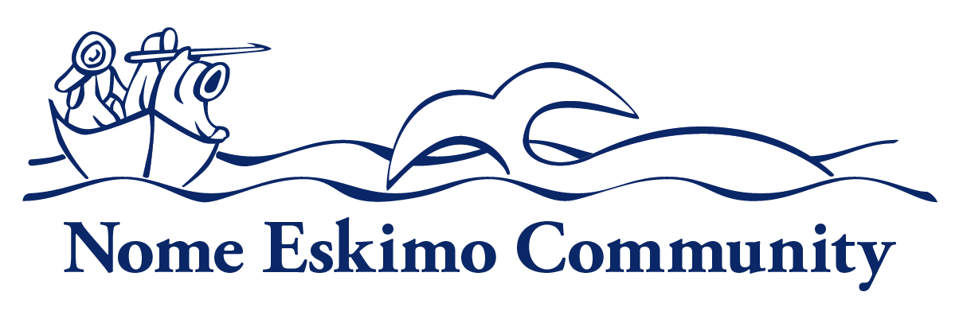

Deputy Director

Department:  Administration | Reports To:  Executive Director | Status:  Regular, Full Time
Location:  Nome | FLSA:  Exempt | Pay Range:  13, 14, 15

Purpose of Position
This position is responsible for providing leadership and support to NEC’s Youth Services, Tribal Services, Housing and Family Services Departments. Will work closely with the Executive Director, Tribal Council and management staff in the overall planning, development and implementation of the Tribal programmatic goals. This position will be tasked to coordinate multiple administrative projects, functions, and priorities on behalf of the tribe.

Uphold the organization’s mission, and corporate values as well as demonstrate understanding of and compliance with organization’s policies and procedures.

Essential Functions
- Provide leadership and supervision to NEC’s Youth Services, Tribal Services, Housing and Family Services (ICWA) Departments and assist the Executive Director with the day-to-day management of NEC. Will ensure personnel are properly supervised, program plans and budgets are properly managed and required reports are completed as scheduled while ensuring compliance with grants and contracts.
- Responsible for developing and monitoring NEC’s youth education and activities as well as serving as NEC’s Child Care Development Fund Administrator and manager of the Child Care Development Fund Block Grant. Will also ensure the ILMS Grant is managed and submitted annually in coordination with Kegoayah Kozga Library.
- Assist the Executive Director for managing, developing and monitoring the NAHASDA Grant, provide leadership to the Housing Department and properly manage Housing Property in the service area.
- Provides supervision and direction to department staff by selecting, training and coaching employees, performance management and provides hiring and termination recommendations to the Executive Director.
- Responsible for making sure all required grant reporting requirements are met, reports are complete and submitted timely to ensure NEC is in good standing with all funders.
- Coordinate the assessment of tribal programs and initiate improvements in order to meet the needs and better serve the tribe. Will also monitor state and federal legislation that impacts programs, services and tribal members.
- Create, implement and manage a strategic communication plan to improve regular and consistent communication with NEC’s tribal membership.
- Seek, write, edit and submit grant opportunities for federal, state, local and private grants to assist the Tribe in advancing departmental goals and objectives.
- Develop working relationships with local organizations, federal and state agencies and advocate for programs and funding on behalf of the tribe.
- Serve as Acting Executive Director in his/her absence and assist with day to day operations at NEC and represent NEC at various meetings and/or functions as needed.
- Other duties as assigned.

Personal Traits:
Employees of Nome Eskimo Community are expected to promote the organization’s mission and vision. Employees are expected to demonstrate integrity, professionalism, accountability, cooperation with and consideration of others.

Knowledge and Skills
All employees are expected to have general knowledge of Alaskan Native culture, traditions, history, and needs as well as customer service skills and the ability to manage their time and organize their work to ensure efficient performance. In addition, all employees should have a general knowledge of computers, copies, fax machines, and typical software, the ability to follow policy, procedure, instruction, communicate regularly with their supervisors, and the ability to understand and manage confidentiality.

Specific knowledge, skills and abilities required for position:
- Knowledge of NEC programs and services
- Knowledge of cost principles and procedures regarding federal agreements
- Skill in oral and written communication
- Skill in establishing and maintaining cooperative working relationships with others
- Skill in grant research, development, submission and compliance
- Skill in budgeting, research, writing and verbal communication skills
- Ability to manage multiple priorities, to work well under pressure and with other people.
- Ability to produce public communication
- Ability to analyze and provide recommendations to implement regulations, statutes, policies and procedures
- Ability to maintain strict confidentiality regarding employee information and exercise good judgment in decision making
- Ability to operate a computer and applicable programs
- Ability to self-motivate and work with minimum supervision

Minimum Qualifications
Education: Bachelor’s Degree in Business Administration or Management, Tribal Management or an equivalent degree is required. Applicable year for year experience may be substituted for degree requirement.

Experience: At least four years’ experience in management at a Tribal Organization working with federal grants and contracts or equivalent experience is required as well as four years supervisory experience. Previous grant writing experience is highly desired.

Additional Requirements or Credentials:
- Must have a valid Alaska Driver’s License

Physical Requirements and Working Conditions:
- Must be able to lift at least 20 pounds
- Work is conducted in a standard office environment.
- Will be required to work outside the traditional work schedule
- Occasional Travel is required
- Use hands and arms to operate office equipment
- Sit more than half the workday
- Bend, stretch, twist, crouch and/or reach
- View electronic monitors and type for prolonged periods of time

This job description is intended to convey information essential to understanding the scope of the job and the general nature and level of work performed by job holders within this job. But, this job description is not intended to be an exhaustive list of qualifications, skills, efforts, duties, responsibilities or working conditions associated with the position.

Internal Approvals

_____________________________________
Printed Name of Incumbent

Signature of Incumbent Date

When possible, NEC will extend a Hiring Preference for employment to Alaskan Natives and Native Americans in accordance with section 7 (b) of Public Law 93-638, the Indian Self-Determination Act. NEC is also a drug free workplace. When required, applicants may be required to pass a criminal history check. Applicants that do not pass pre-employment requirements will not be considered.

