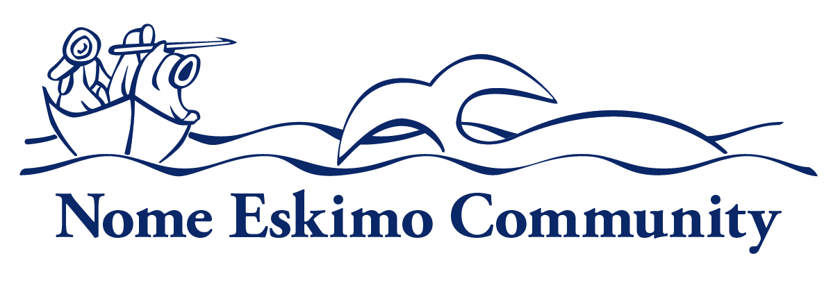

Environmental Manager

Department:  Administration | Reports To:  Executive Director | Status:  Regular; Full Time
Location:  Nome | FLSA:  Non-Exempt | Pay Range:  11, 12, 13

Purpose of Position Purpose of Position
Under limited supervision, responsible for the planning, implementation and management of the NEC’s Environmental Program, Tribal Transit and IT support, ensuring compliance with project and grant requirements.

Uphold the organization’s mission, and corporate values as well as demonstrate understanding of and compliance with organization’s policies and procedures.
Essential Functions
- Serve as program manager for NEC’s Indian Protection Agency Environmental General Asstiance Program Grant (IGAP) and manage NEC’s multi-year GAP Plan. Work with regulatory agencies to ensure program is in compliance with federal regulations, meet programmatic reporting requirements and provide supervision to seasonal program staff.
- Research and make recommendations and provide technical assistance to NEC Administration and the Tribal Council on environmental any natural resources issues that may impact community health such as air quality, dust control, etc.
- Conduct field research studies in water and air quality, and other field research.
- Coordinate with local, city, state and federal agencies to provide comments or assistance in the development of management plans, compliance issues and/or other project plans as needed. Review and as needed, comment on state and federal permits needed for projects that may have an environmental impact on subsistence or natural resources.
- Become knowledgeable of state and federal regulatory programs related to environmental quality, remediation, subsistence, climate change, and other issues pertaining to the natural resources of our area.
- Develops and submits quarterly EPA grant, Tribal Transit Grant and funding related reports, and program reports to the Tribal Council.
- Other duties as assigned

Optional: NEC is also seeking help with if the candidate has experience or wants to learn:
- Manage NEC’s Tribal Transit program including supervision of staff, vehicle maintenance, required reporting and applying for applicable grants.
- Provide technical assistance with IT related issues, support, and provides recommendations for improvements. Maintain NEC web-site, Facebook page, and email access for staff and Tribal Council.

Personal Traits:
Employees of Nome Eskimo Community are expected to promote the organization’s mission and vision. Employees are expected to demonstrate integrity, professionalism, accountability, cooperation with and consideration of others.

Knowledge and Skills
All employees are expected to have general knowledge of Alaskan Native culture, traditions, history, and needs as well as customer service skills and the ability to manage their time and organize their work to ensure efficient performance. In addition, all employees should have a general knowledge of computers, copies, fax machines, and typical software, the ability to follow policy, procedure, instruction, communicate regularly with their supervisors, and the ability to understand and manage confidentiality.

Specific knowledge, skills and abilities required for position:
- Knowledge of NEC programs and services
- Knowledge and understanding of state and federal environmental regulations and policy, knowledge of federal tribal transit regulations and policy.
- Must have the ability to develop research plans, conduct research, interpret and understand scientific data and legal documents, and have mathematical and scientific research abilities.
- Must be able to monitor and analyze water quality and air quality, including testing potentially affected creeks and rivers, and other field research as needed.
- Knowledge and experience in the development and implementation of federal grants, contracts and contract compliance. Ability to comply with all applicable Federal or Tribal statues, regulations or ordinances.
- Must possess computer knowledge and skills including Internet usage, Microsoft Excel and Word, databases and GIS mapping software. Must have ability to produce public communication.
- Skill in oral and written communication, skill in establishing and maintaining cooperative working relationships with others.
- Must be dependable, self-motivated, and work with minimum supervision, and have the ability to manage multiple priorities.
- Other duties as assigned.

Minimum Qualifications
- Education: Bachelor’s degree in biology, environmental science or similar field is required. Progressively responsible professional work experience in environmental, natural resources or a related field may be substituted for the degree requirement on a year-to-year basis.
- Experience: Must have at least 2 years comparable work experience or demonstrated proficiency at NEC.

Additional Requirements or Credentials:
- Must have a valid Alaska Driver’s License

Physical Requirements and Working Conditions:
- Must be able to lift at least 50 pounds
- Work is conducted in a standard office environment, with seasonal outside work in the field.
- May be required to work outside the traditional work schedule occasionally
- Use hands and arms to operate office or field equipment
- Sit more than half the workday, view electronic monitors for prolonged periods of time
- Stand and/or walk less than half the workday, ability to bend, stretch, twist, crouch and/or reach
- Limited travel is required

This job description is intended to convey information essential to understanding the scope of the job and the general nature and level of work performed by job holders within this job. But, this job description is not intended to be an exhaustive list of qualifications, skills, efforts, duties, responsibilities or working conditions associated with the position.

Internal Approvals

_____________________________________
Printed Name of Incumbent

Signature of Incumbent Date

When possible, NEC will extend a Hiring Preference for employment to Alaskan Natives and Native Americans in accordance with section 7 (b) of Public Law 93-638, the Indian Self-Determination Act. NEC is also a drug free workplace. When required, applicants may be required to pass a criminal history check. Applicants that do not pass pre-employment requirements will not be considered.

