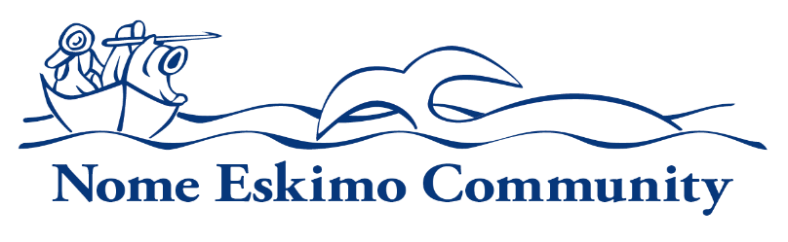

ICWA Coordinator
Department:  Family Services | Reports To:  Family Services Director | Status:  Full-Time or Part-time
Location:  Nome | FLSA:  Non-Exempt | Pay Range:  6, 7, 8

General Purpose

Under general supervision, provides case management and program support to achieve the goals and objectives of the Family Services Department under the Indian Child Welfare Act (ICWA) and the Tribal-State Compact Agreement.

Uphold the organization’s mission, and corporate values as well as demonstrate an understanding of and compliance with organization’s policies and procedures.

Essential Functions

- Provide support services to NEC tribal families in compliance with Tribal In-Home Case Plans/Office of Children’s Services (OCS) case plans and need.
- Support ICWA Specialists in case-related activities as outlined in the program goals and objectives governed by the Indian Child Welfare Act (ICWA).
- Prepare, assemble and maintain case files for ICWA case management.
- Process protective service reports per the Tribal Agreement of Confidentiality.
- Participate in Initial Assessment (IA) investigations with OCS investigators as assigned.
- File formal Court Interventions and serve parties as instructed by the assigned ICWA Specialist.
- Maintain statistical information for program reporting requirements.
- Calendars meetings, case reviews, court hearings and internal scheduling needs.
- Provides coverage for case meetings, reviews and court hearings as needed and appropriately document events.
- Maintains confidential client records per required standards.
- Conduct Diligent Relative Searches and Ongoing Placement Searches to identify potential relative placements for tribal children in out-of-home care in compliance with the Fostering Connections to Success and Increasing Adoptions Act of 2008 and applicable policies and procedures. Conduct database searches utilizing State approved search systems.
- Provide support and coordination for teleconferences, in-person meetings, and special projects associated with the Tribal-State Compact Agreement and applicable Support Services Funding Agreements (SSFA) as needed.
- Assist tribal members in acquiring supportive services to support compliance with State or Tribal case plan requirements.
- Conduct safety assessments of unlicensed relative homes as assigned.
- Conducts family contact visits in compliance with applicable state and federal protocols and procedures.
- Perform routine administrative support functions for the office.
- Other duties as assigned.

Personal Traits

Employees of Nome Eskimo Community are expected to promote the organization’s mission and vision. Employees are expected to demonstrate integrity, professionalism, accountability, cooperation with and consideration for others.

Knowledge and Skills

All employees are expected to have general knowledge of Alaskan Native culture, traditions, history, and needs as well as customer service skills and the ability to manage their time and organize their work to ensure efficient performance. In addition, all employees should have a general knowledge of computers, copies, fax machines, and typical software, the ability to follow policy, procedure, instruction, communicate regularly with their supervisors, and the ability to understand and manage confidentiality.

Specific knowledge, skills and abilities required for position:

- Experience in child protective services, knowledge of ICWA court proceedings preferred, and internal administrative policies and procedures.
- Must possess strong oral and written communication, and organizational skills. Knowledge of Microsoft Word, Windows and Internet skills required.
- Must be dependable, self-motivated, possess the ability to work with others in a
Cross-cultural and rural setting, and work with minimum supervision.
- Ability to track complex networks and evaluate information for decision making purposes.
- Ability to maintain strict client confidentiality.
- Must be willing to travel and work evenings and weekends as necessary.

Minimum Qualifications

- Education: Associate degree in applicable field preferred. Progressively responsible professional work experience in a related field may be substituted on a year for year basis for degree requirement.
- Experience: At least 2 years of experience in child protective services, comparable work experience or demonstrated proficiency at NEC is required

Additional Requirements or Credentials:

- Must have a valid Alaska Driver’s License

Physical Requirements and Working Conditions

- Work is conducted in a standard office environment.
- Must be able to lift at least 20 pounds.
- May be required to work outside the traditional work schedule occasionally.
- Occasional Travel is Required

This job description is intended to convey information essential to understanding the scope of the job and the general nature and level of work performed by job holders within this field. This job description is not intended to be an exhaustive list of qualifications, skills, efforts, duties, responsibilities or working conditions associated with the position.

Internal Approvals

_____________________________________
Printed Name of Incumbent

Signature of Incumbent Date

When possible, NEC will extend a Hiring Preference for employment to Alaskan Natives and Native Americans in accordance with section 7 (b) of Public Law 93-638, the Indian Self-Determination Act. NEC is also a drug free workplace. When required, applicants may be required to pass a criminal history check. Applicants that do not pass pre-employment requirements will not be considered.

