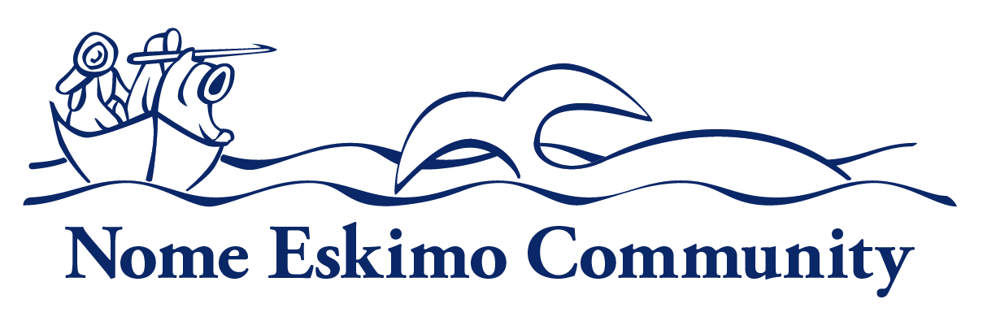

Youth Services Intern

Department:  Youth Services | Reports To:  Youth Service Specialist | Status:  Temporary
Location:  Nome, Alaska | FLSA:  Non-Exempt | Pay Range:  4-5-6

Purpose of Position
Under general supervision, will provide administrative and program support for youth activities during the summer months.

Uphold the organization’s mission, and corporate values as well as demonstrate understanding of and compliance with organization’s policies and procedures.
Essential Functions
- Provide administrative and program support for Nome Eskmio Community’s education and youth programs and activities.
- Assist in the coordination of cultural, subsistence, education, and athletic activities for youth.
- Participate in and/or organize activities to promote healthy families, children, and a sense of community well-being, as needed.
- Assist with field research projects and community education, as needed.
- Maintain and compile required statistical information for reporting requirements.
- Assist with the development of program plans and reports for future youth activities.
- Other duties as assigned

Personal Traits:
Employees of Nome Eskimo Community are expected to promote the organization’s mission and vision. Employees are expected to demonstrate integrity, professionalism, accountability, cooperation with and consideration of others.

Knowledge and Skills
All employees are expected to have general knowledge of Alaskan Native culture, traditions, history, and needs as well as customer service skills and the ability to manage their time and organize their work to ensure efficient performance. In addition, all employees should have a general knowledge of computers, copies, fax machines, and typical software, the ability to follow policy, procedure, instruction, communicate regularly with their supervisors, and the ability to understand and manage confidentiality.

Specific knowledge, skills and abilities required for position:
- Knowledge of Microsoft Office Products such as Word and Excel
- Skill in oral and written communication
- Skill in establishing and maintaining cooperative working relationships with others
- Ability to maintain client confidentiality

Minimum Qualifications
- Education: Must be a student in good standing and enrolled in an undergraduate degree program for the fall semester or High School Diploma/GED

Additional Requirements or Credentials:
- Driver’s License Preferred
- Obtain First Aid/CPR certification within 30 days of hire.
- Must receive 7 hours of on the job training prior to start of NEC Outdoors Club

Physical Requirements and Working Conditions:
- Work is conducted in a standard office and outdoors environment.
- May be required to work outside the traditional work schedule occasionally
- Travel is not required
- Bend, stretch, twist, crouch and/or reach
- Lift or carry unaided between 25 and 50 pounds

This job description is intended to convey information essential to understanding the scope of the job and the general nature and level of work performed by job holders within this job. But, this job description is not intended to be an exhaustive list of qualifications, skills, efforts, duties, responsibilities or working conditions associated with the position.

Internal Approvals

_____________________________________
Printed Name of Incumbent

Signature of Incumbent Date

When possible, NEC will extend a Hiring Preference for employment to Alaskan Natives and Native Americans in accordance with section 7 (b) of Public Law 93-638, the Indian Self-Determination Act. NEC is also a drug free workplace. When required, applicants may be required to pass a criminal history check. Applicants that do not pass pre-employment requirements will not be considered.

